First page:

Technical Submittal – R0
Dec 2019
Prepared for Endress + Hauser, Waluj Aurangabad

WATER COOLED SCREW CHILLERSYSTEMS

Contactor Name:
Shubhshree Engineering and Constructions Pvt Ltd
401-404, Sai Business centre, Osmanpura
Aurangabad-431005, MH, India.

Supplied Name: NIHVA Technologies Pvt Ltd

Prepared by,
Ms. Varsha
8551091333
NIHVA Technologies Pvt Ltd

Table of Contents

- Introduction
- Product Sample Photo
- Scope of Supply
- BOQ, Technical Specification and compliance
- GA Drawing – Preliminary
- Technical submittals
- Job Information
- Part Load Performance on IPLV & NPLC
- Technical (mechanical + Electrical) Speciation
- Control Panel & Chiller plant manager Technical specification.
- General Data of chiller and Electrical drawings.
- Factory sample test reports
- Optional Items & Deviation List
- Catalogues

- Introduction: NIHVA Technologies Pvt Ltd, Pune
NIHVA’s Head Office & manufacturing facility is located in Pune in Maharashtra (India) & sales office at various metro cities.
NIHVA is young and growing company, having experience of 7 years in industrial market. NIHVA specializes in providing integrated solutions in Door Automation & Automation Solutions.
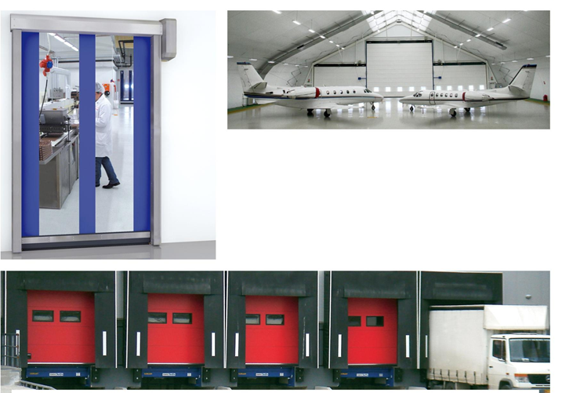

Apart from this NIHVA is also equipped in providing water management and drainage solutions (external and internal).

- Product Sample Photos

- Dock Levelers

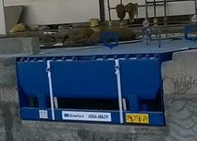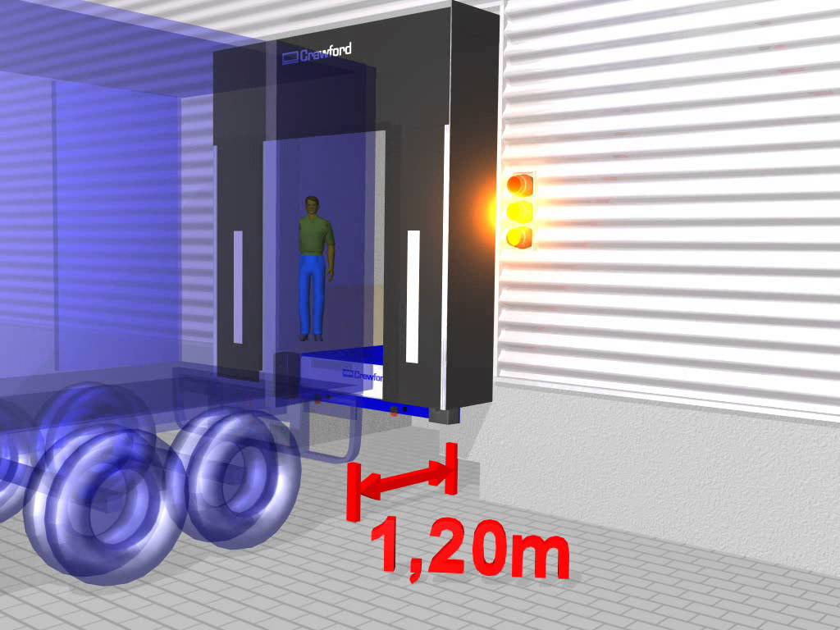

- Scissor Lift

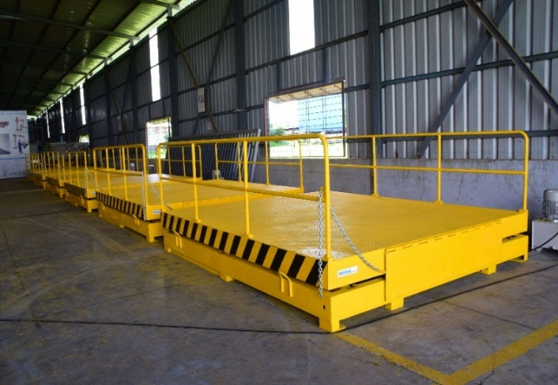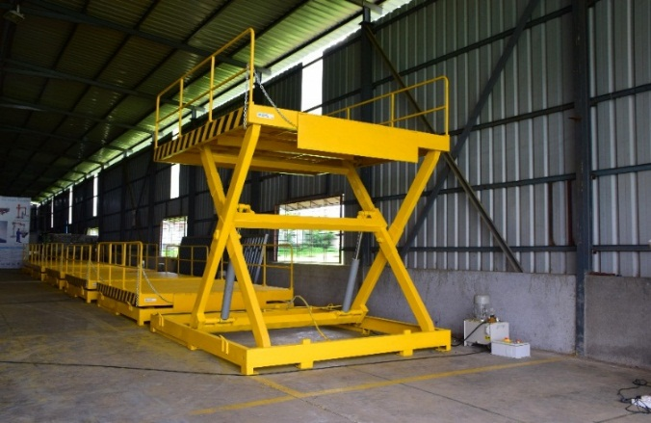

- Dock Shelters

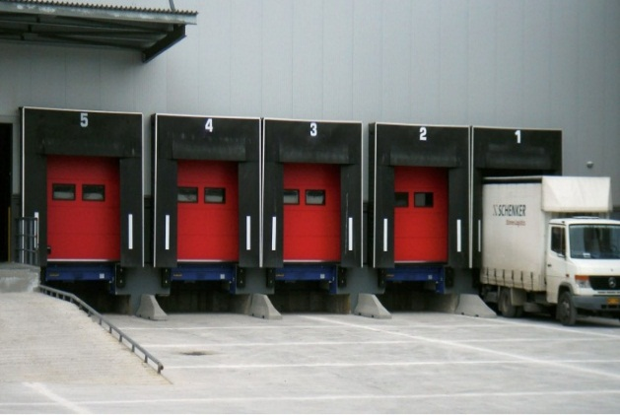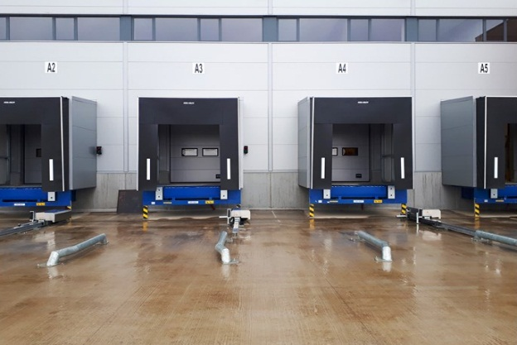

- Scope of Supply
S. N | Products | Size | Qty
1 | NIHVA ASSA ABLOY Dock Leveler | (W) 2000 mm X (H) 2500 mm | 4
2 | NIHVA Hot Dip Galvanized Scissor Lift | (W) 2000 mm X (L) 2500 mm | 4
3 | NIHVA ASSA ABLOY Retractable Dock Shelter | (W) 3450 mm X (L) 3600 mm | 4

- BOQ, Technical Specification and compliance
Dock Levellers: Supply and fixing Electro- Hydraulic Dock Leveller of hot deep galvanised steel ) type radius lip with pair of super bummer of Approved make of size width 2000mm X 2500mm. Carrying capacity: point load of 6T, UDL of 15T and comprising of CE European certification built in conformity with EN 1398, platform with hinged lip made of profiled and anti-slip steel, pair of super bumpers - 150mm x 80mm x 400mm with heavy steel support, Hydraulic power pack suitable for UDL of 10T, EN1398 totally concentrated on one axle of fork lift truck, divided on two wheel, EN 1398 totally concentrated on one axle of fork lift truck, divided on two wheel prints of 150x 150mm at 1m distance.
interlocked with sectional door and scissor lift.
Scissor Lift: Design, Fabrication, Supply, Installation, Commissioning, packing, transportation to site, unloading, furnishing of final drawings and manuals, handling at site, erection, commissioning, performance demonstration and performance acceptance etc. of 6 Ton (UDL) capacity electro hydro operated scissor lift of hot deep galvanised steel, having platform size 2000 mm x 2500 mm & lifting height Max. 1200 mm from Ground level to make the system complete in all respects with necessary Safety Railing of 1 mtr high all around platform as per manufacturers specifications including all electrical system units, hydraulic units, controls, connections, all safety bars, controls, fittings & accessories required for operations, tools & tackles, labours, machineries etc complete.
interlocked with sectional door and dock leveller.
Dock Shelter: Providing & fixing approved make Retractable Dock Shelters supplied with :- Articulated Galvanized steel zinced retractable structure anti pinch retraction arms the front panels are made of high resistance black PVC reinforced with a double weaving of polyester that works likes a spring in order to seal the vehicles of different shapes. as per specified RAL code. Overall Dimension: 3400mm x 3500mm x 660mm front opening width : 2140mm + 630 side flaps on both sides Height : 2500mm + 1000mm top flap
- GA Drawing – Preliminary
Note: We will provide drawing after receiving confirmed purchase order.
- Technical submittals
- Job Information
- Part Load Performance on IPLV & NPLC
- Technical (mechanical + Electrical) Speciation
- Control Panel & Chiller plant manager Technical specification.
- General Data of chiller and Electrical drawings.
Dock Levellers:
Sr. No | Description | Specification
1 | Size | (W) 2000 mm x (H) 2500 mm
2 | Quantity | 4 Nos
3 | Capacity | 15 T
4 | Control Unit Protection Class | IP54
5 | European Standards | EN 1398
6 | Coating | RAL 5010, Hot dip galvanized
7 | Control unit | Supervision 105, 105A, i105, i305 Service & fault Indicator
8 | Vertical working range  Rise above dock  Fall below dock | 250 - 620 mm  270 - 350 mm
9 | Platform tear-plate thickness with platform reinforcements according to the load capacity | 6/8, 8/10 mm
10 | Lip material & length | Steel, 400 / 500 mm
11 | Nominal voltage | 400V 3-phase

Scissor Lift:
Sr. NO | Description | Specification
1 | Capacity | 6 Ton (UDL)
2 | Platform Size | (W) 2000 mm X (L) 2500 mm
3 | Shut Ht | 1000 mm
4 | Max Ht | 2200 mm
5 | Lift Ht | 1200 mm
6 | Safety Railing | All side only
7 | Manual Lip | 3 Piece (240 + 1500 + 240) - 1 Side Only
8 | Maintenance Stopper | 2 NOS
10 | Push Button Pendent | Flexible pendent with 5 mtr Cable - 1 No
11 | Control Panel | Outside pit - 1 No
13 | Safety Bellow | All side
14 | Power Pack Inside Pit with Buzzer | 15 HP, 3 Phase - Eaton make
15 | Hydraulic Cylinder | Two numbers with Bore 150 X stroke 500 mm - Eaton make
16 | Hot Dip Galvanised | IS 2629 / EN ISO 1461 / As per ASTM
17 | Hose | Parker Hoses
19 | Cable | Polycab cables
20 | Hydraulic Oil | Grade 68 - 125 Ltr

Dock Shelter:

Sr. No | Description | Specification
1 | Size | (W) 3450 mm x (H) 3400 mm
2 | Quantity | 4 Nos
3 | Normal Width x Normal Height | 3450 mm x 3400 mm
4 | Normal Depth | 600 mm
5 | Top Curtain | 1000 mm
6 | Side Curtain | 600 mm
7 | Curtain Colour | Black
8 | Top and Side curtain | Double Layer High Quality Polyester
9 | Thickness | 3.0mm
10 | Flammability all curtain | DIN 75200
11 | Frame Material | Aluminum

- Factory Sample Test Reports:

Attached.

- Optional Items & Deviation List

S. N | Products | Deviation
1 | NIHVA ASSA ABLOY Dock Leveler  (W) 2000 mm X (H) 2500 mm | No
2 | NIHVA Hot Dip Galvanized Scissor Lift  (W) 2000 mm X (L) 2500 mm | No
3 | NIHVA ASSA ABLOY Retractable Dock Shelter  Articulated Galvanized steel zinced retractable structure  BOQ: (W) 3450 mm X (L) 3600 mm  front opening width : 2140mm + 630 side flaps on both sides | Aluminium Structure  NIHVA (W) 3450 mm X (L) 3400 mm  front opening width: 2250mm + 600 side flaps on both sides

- Catalogues: Attached in mail

Sr. No | Product | Earlier BOQ | Revised BOQ
1 | Dock Leveler | NIHVA make | ASSA ABLOY (Crawford)
2 | Scissor Lift | Quoted as per BOQ | Revised: Safety Edge & bellows added
3 | Retractable Dock Shelter | ASSA ABLOY (Crawford) | ASSA ABLOY (Crawford)  Revised: front patch should be reflective white strips
4 | Overhead Sectional Door | ASSA ABLOY (Crawford)  Lift : Vertical Lift | ASSA ABLOY (Crawford)  Lift : Standard Lift
5 | High Speed Door | ASSA ABLOY (ALBANY)  Model : RR300S | ASSA ABLOY (ALBANY)  Model : HS9020G (with Anti crash Mechanism, Radar Sensor)
6 | Motorised Rolling Shutter | Make: NIHVA  Single skinned GI Rolling Shutter  Profile - Curved  Indirect Drive Motor : PRC Make | Make: Option 1 : NIHVA  Single skinned Galvalume Rolling Shutter  Direct Drive Motor : German Make  Profile: Flat  Make: Option 1 : Teckentrup  Double skinned Rolling Shutter  Direct Drive Motor

